Media Design Document

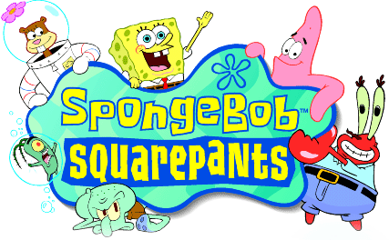

Gameboy Advanced

Written by

Chris Rundell, AGB Lead Artist

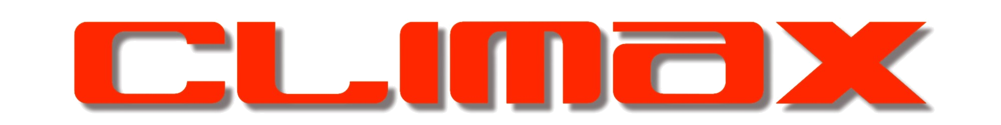
(Fareham)

For

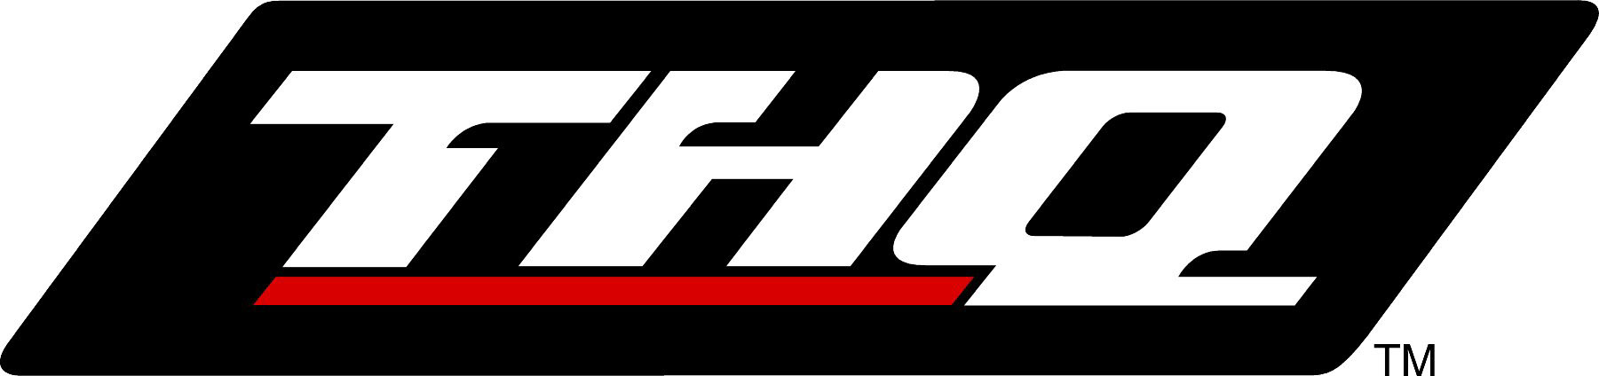

Overview

Format: Playstation & Gameboy Advance.

This document deals with Gameboy Advanced only.

Media

Cartridge 4Mb / 32 Mbit capacity

Memory Capacity for Art Data

N/A

Rendering Engine

Screen resolution is 240 x 160.
Parallax Scroll Engine
Sprite System

Art Style Guide

The main aim for the artwork regarding Spongebob Square Pants AGB will be to adhere to the Playstation version while remaining faithful to the cartoon series.

SB AGB will be a 2D platformer using rendered out characters and backgrounds from the PSX version/max. The AGB version will also require additional animation unique to this platform.

There will be a shared resource of 8 bit backgrounds, pallets and sprite elements across the game allowing the reusability of artwork at any given time. This increases the general spectrum of resources throughout the Spongebob world

The whole SB experience should look organic; backgrounds and foregrounds and sprites should look natural and belong to one layer while keeping faithful to the cartoon

Interactive scene objects, pickups and buttons/switches should be consistent and/or have a visual cue e.g. highlighting, outlining, animating.

File Name Conventions

To be confirmed.

Directory Structure

As yet to be put in place.

Version Control

VSS Version 6.0

Tools

“Off-the-Shelf”

These tools will be detailed later on in the Software Resource Requirements section.

Proprietary

Level editor specific to level building on Spongebob AGB.

Resources

Human Resources
Nick Dry Game Designer
Level Design
Front end Design
Story integration.

Chris Rundell Lead Artist
Characters, Levels, Front end.

Shaun Pearson Artist
Characters, Levels.

Wai Hung Wan Artist
Characters, Levels.

Hardware Resources

N/A

Software Resources

3D Studio Max. v3.1 x3
Character Studio v2.2 x3
Adobe Photoshop v.5.5 x3
P2 x3
Paintshop Pro v6.0 x3
Dpaint x3
Promotion x3
Level Editor (In house) x3
UV botherer x3

Game Engine Restrictions on Art Creation

FMV

Not Applicable.

Front End & Menu’s

THQ logo
Spongebob logo
To be supplied by THQ:
Legal screen text.

Source and Target Textures

8bit backgrounds/Sprites with palette sharing used when possible.

Choice of fonts to be decided.

All art work must remain true to the original resources supplied. AGB artists can refer to the resource directory for a style guide.
THQ will be supplying resource material directly from Nickelodeon consisting of background cells and animation cells for Spongebob characters. All menus and controller set up screens should be comprehensible to children. Navigation through setup and option screens should be straightforward and all icons/fonts should be easily recognisable/legible.
All logos must be consistent with those of the manufacturer, license etc.

Source and Target Models
The front end will primarily consist of 2D layers. The Spongebob opening credits will act as a reference for fonts and background visuals.

Source and Target Animations
Front end animations will be limited to animated text and screen swipes/Fades.

In-Game Control Panel & Menu’s

These will be kept to a minimum:
Spongebobs health status*
Number of lives*
Current ammo (related to current weapon/skill item).

*Appears on screen when Spongebob is hurt or loses a life.

Source and Target Textures

8bit sprites with palette sharing.

Source and Target Animations

Any animations here will be minimal and have no art requirements.

Environments

The game will be spilt in to 6 worlds containing 4 levels per world. Early constraints predict we will have no higher than 2 tile sets for each world with a unique pallet for each set.

This will give us a total count of 12 Tile sets and 12 8bit pallets throughout the game.

Proposed Levels (subject to change)

- Bikini Bottom
- Jelly Fields
- Sandy’s Bio- Dome
- Fish Hooks/Park
- City/Tuna Warehouse

'Too the centre of the Earth'
- Acrid Air Pockets
- Cavernous Canyons
- Thermal Tunnels
- Lava Fields

‘Rock Bottom’
- Desert Wasteland
- Precipice Canyon
- Graveyard
- Inside the whale

- ‘Ruins’
- Kelp Jungle
- Naughty Natives
- Ruins
- Neptune’s Temple

- ‘Industrial’
- Polluted Seabed
- Oil Rig
- Tuna Canning Ship

- ‘Kelp World’ (Theme Park) - Sub Bonus Levels
- Roller Coaster
- Big Wheel
- Ghost train
- Tunnel of Love
- Big Top

Source and Target Textures

8bit tiled backgrounds and Sprites with palette sharing.

Source and Target Models

The game levels are built from a library of tiles which are 1024 8x8 tiles in size. Each tile can utilise a pallet of 256 colours per tile.

Source and Target Animations

Animated background objects will be treated as sprites

Characters/Vehicles

All characters on screen will be made up from animated sprites ranging from 8x8 to 64x64 pixels in size.

Characters

Gary
Patrick
Mr. Krabs
Sandy Cheeks
Mrs Puff
Pearl
Squidward
Plankton
Mermaid Man
Barnacle Boy
Neptune
Muscle Beach crabs.
Jellyfish

Vehicles

Bikini Bottom bus.

Source and Target Textures

8 Bit sprites with a shared palette when possible.

Source and Target Models

Please refer to Dave’s TDD for a full description.

Source and Target Animations

Animations will be created by Steve Crocker, based on resources from the series, using Character Studio with 3DS Max. The GBA artists will then render these out.

Pickups/Weapons

There are no weapons in Spongebob, however he will have various items to repel hazardous creatures or remove obstructions in his path.

- Balloon – Used to gain access to previously unexplored areas of the levels
- Bubble Mixture – Temporary platform creator
- Diving Helmet – To breath out of water
- Coral Blower – Long range weapon, collecting hard to reach pick ups, destroying walls
- Net – Catching assorted ammo for the Jelly Gun
- Jelly Gun – Long range weapon, converts and fires Jellyfish at monsters
- Glasses – See invisible creatures, protects against certain Jellyfish
- Jam Jar – Collecting and saving prized Jellyfish (1 per Level)
- Squeaky Boots – Temporary protects SB from electrocution and hazardous surfaces
- Mermaid Man and Barnacle Boy Special Superhero Ring – Temporary invulnerability
- Gary de Snail – Activating inaccessible switches and racing
- Pizza – Deliver pizza to it’s designated customer.
- Tool Kit/ Oil Can – Fixing and repairing interactive objects
- Kelp Gum – Nothing apart from blowing bubbles (extra idle)
- Disguise – Sneaking past specific opponents
- Junk Food – Restoring depleted health, Salty Shakes and Salty Fries

Source and Target Textures

8bit tiled backgrounds and Sprites with palette sharing.

Source and Target Models

8bit sprites using a shared pallet

Source and Target Animations

To be designed

Production Pipelines

FMA

Rather like the Playstation we will be using a set number of animated sprites and text to convey the mission objectives Mermaid Man and Barnacle Boy set for Sponge Bob. In all there will be 6 sequences, one to introduce the game objective and five more that are specific to the level objectives.

The use of sprites rather than short animation sequences will mean we can reuse material for further mission objectives.

Front End & Menu’s

The front end will consist of 8bit 240 x 160 2D screens. There should be no animation requirements here.

In Game Control Panel & Menu’s

These will be kept to a minimum:
Spongebobs health status*
Number of lives*
Current ammo (related to current skill item).

*Appears on screen when Spongebob is hurt or loses a life.

Bitmaps are no larger than 64 x 64 and 16 colours. They can use opacity, transparency and animation. Spongey’s health will be displayed as a series of facial expressions. Five in total ranging from a smile (full health) to a dehydrated, exhausted look (1 health).

Environments

Please also refer to Kevin Martins MDD

Environments will be created in, then rendered out from, 3D Studio max and converted in to 8 bit tiles. These will then be assembled using the in house map editor.

Characters/Vehicles

All NPC’s will be sprite based with a maximum of around 16 frames of animation each character movement except for Sponge Bob himself who will utilise far more frames than any other NPC throughout the game. Sprites will use a fixed 8 bit pallet which means we shall be able to utilise the characters at any point during the game.

Character Expressions

Please also refer to Kevin Martins MDD

As the extent of animation allowed/allocated is still undetermined the following is a list of sprites features we would like to see included in SB.

Due to the resolution of the AGB it will be extremely hard to maintain the detail of the facial expressions used in the Playstion version, however, expressions will be conveyed using specific sprite animations to the AGB version.

Action | Description | Additional AGB Animation
Stunned and dazed | Stars appear and circulate around SB’s head | More emphasis on arm and leg movements – eg SB waves arms more and staggers
Bubbles | Shows fast movement
Speech | Speech bubbles

Communication and Idle Animation

Action | Description | Additional AGB Animation
Laughter | Playing joke or humor | More emphasis on arm movement – eg hands on hips, head held back
Surprised/Scream | Scared/Shocked | Arms and legs outstretched, jumps in air
Stupid | SB confronted with a puzzle or task | Scratching head, finger in mouth
Agitated | SB left alone/idle | Tapping foot, turning to face ‘camera’ looking at imaginary watch, whistling
Talking | Interacting with another NPC | Hand expressions eg- waving arms while communicating. Waving Hello/Good bye

Game Over/Death Animation

Action | Description | Additional AGB Animation
Tears | Scared or upset – eg game over | More emphasis on hand movement – eg rubbing eyes, stamping feet
Shocked | SB Electrocuted | Arms and legs outstretched, jumps in air
Intoxicated | Toxic Hazards | Hands on ground, coughing

Guise

Please also refer to Kevin Martins MDD

Note: The following section is a proposal. Cartridge restrictions may rule out the possibility of any extra/additional animation.

Certain areas of SB may require the character to don certain items of clothing/disguise. Some items will take the form of overlaid sprites other items may require a completely new set of sprites (Depending on memory limitations).

Areas for graphical changes,

Hat or hairpiece
Glasses, these could be sunglasses
Waist - Due to SB’s appearance any clothing area for graphical changes will point towards his waist
Arms - These could be a variation on sleeves (short/long)
Hands - Oversized hands/gloves
Feet - Different types of footwear

Possible other outfits

Tux
Pizza delivery/ Krusty Krab uniform
Deep-sea diving suit
Sailors outfit
Caveman loincloth
Clown’s outfit
Pretend Mermaid Man outfit
The real Superhero outfit

Pickups/Weapons

Skill items will be rendered out 8 bit sprites no bigger than 64 x64 pixels in size.

Special FX

The AGB programmer will predefine these.

